Docker Task 2

Create a dockerfile, docker-compose file which when executed must display your basic details in the website.
Description:
Going to use flask to display basic details in the website. The folder structure would be
my-profile-app-> app Dockerfile docker-compose.yml
app-> app.py templates ->index.html
App.py:
from flask import Flask, render_template
app = Flask(__name__)
@app.route("/")
def home():
return render_template("index.html")
if __name__ == "__main__":
app.run(host="0.0.0.0", port=5000)

index.html:

<html>
<head>
<title>My Profile</title>
</head>
<body>
<h1>Welcome to My Profile Page!</h1>
<p><strong>Name:</strong> Nivedha</p>
<p><strong>Role:</strong> Senior DevOps Engineer</p>
<p><strong>Email:</strong> nivedha@example.com</p>
<p><strong>Goal:</strong> To become a Multi-Cloud Architect</p>
</body>
</html>

Dockerfile

FROM python:3.9-slim
WORKDIR /app
COPY app/ /app/
RUN pip install Flask
CMD ["python", "app.py"]

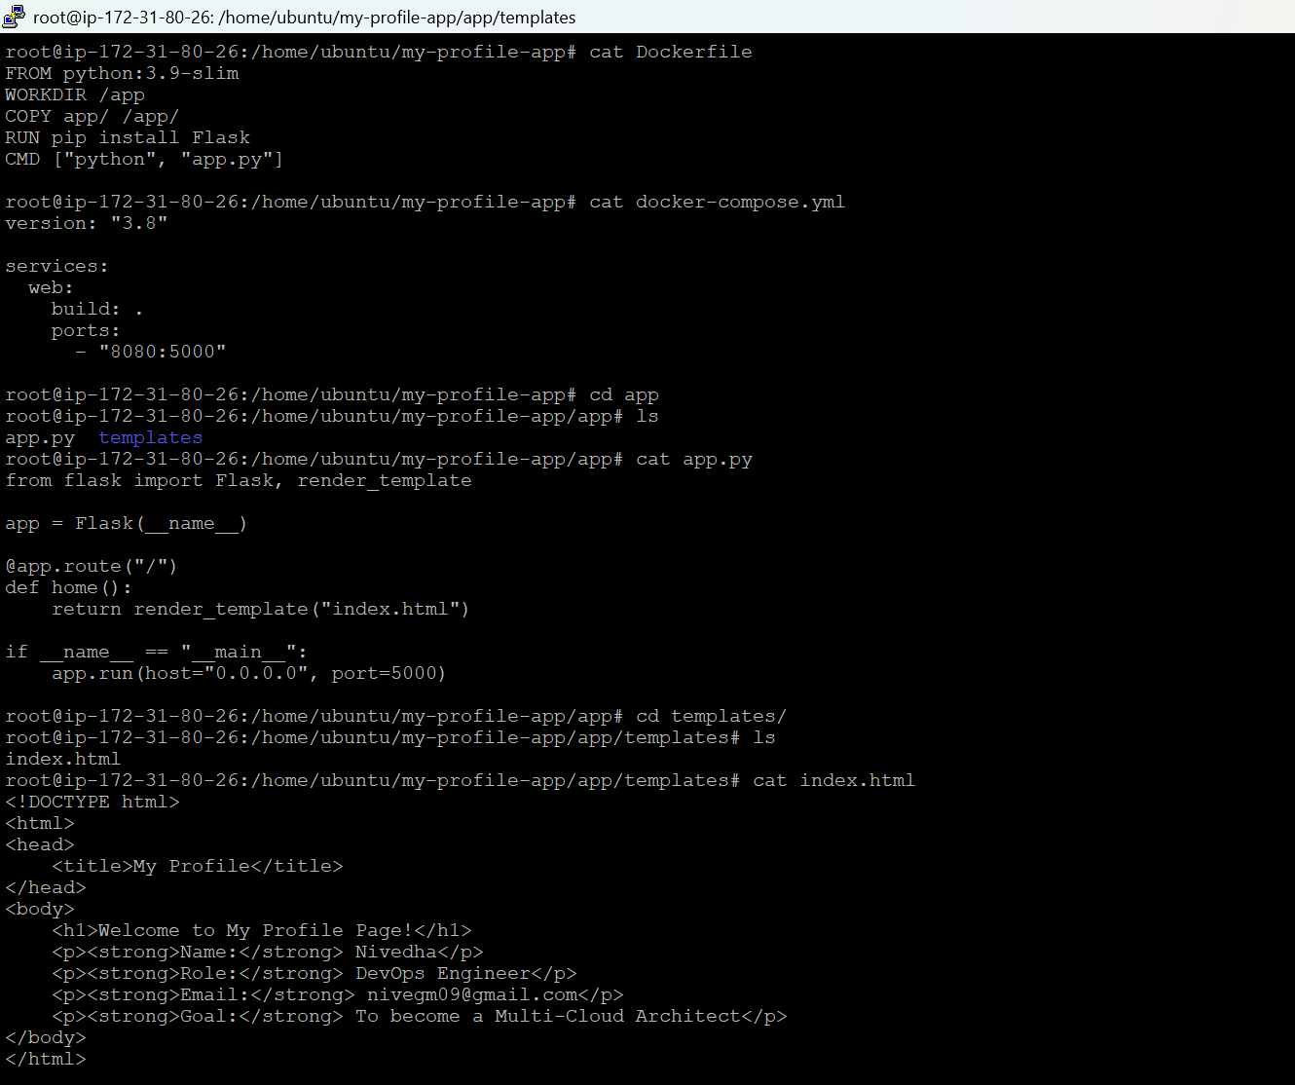

Run
docker-compose up –build
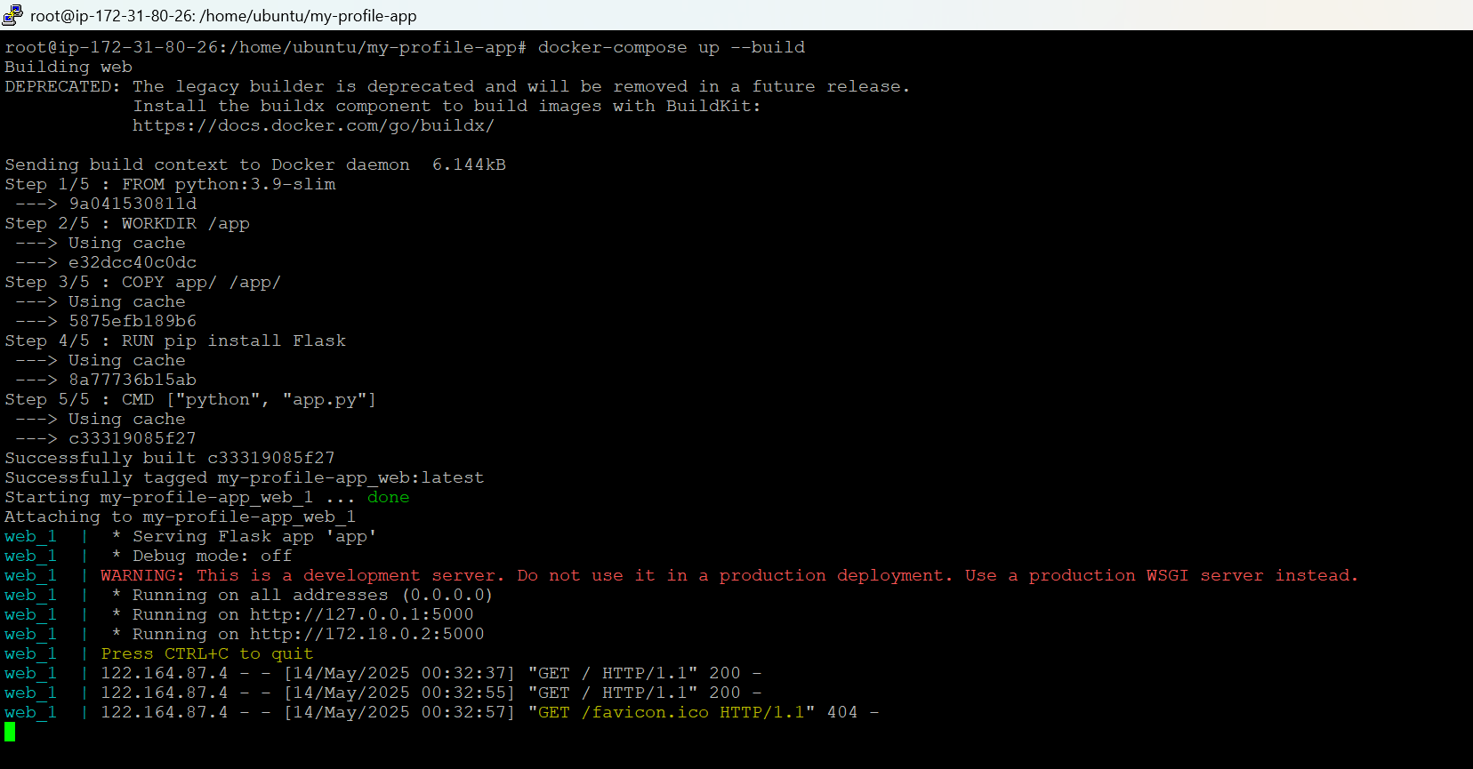

Now visit:
http://3.95.156.36:8080
